Longest Increasing Subsequence

Problem
You are given an array a[] of size n. Find the length of longest increasing subsequences.

Subarray: Continuous block of elements
Subsequences: Part of the array in order. It may or may not be continuous.

Every subarray is a subsequence but every subsequence is not a subarray.

Example
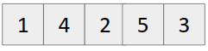
LIS can be {1,4,5} or {1,2,3}
Therefore length of LIS = 3

We define
LIS(i) : Length of longest increasing subsequence ending at ith element.

Therefore, LIS(i) depends on LIS(k), where 0 <= k< i as
If (a[i] > a[k])
then LIS(i) = max( LIS(i), 1+LIS(k) )

Since we can write recurrence relation, hence it has Optimal Substructure Property.

Checking whether it has overlapping subproblem property also..
Making recursion tree
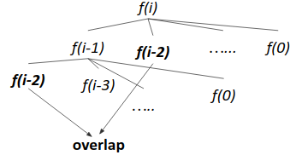
Since f(i-2) repeats, it follows overlapping subproblem property.

Since it follows both optimal substructure property and overlapping subproblem property , hence we can apply dynamic programming here.

Approach (Tabulation)
- Make a dp array and initialize all the dp[i] by 1 {since single element is also an LIS}.
- For every i from left to right, iterate from j=0 to j=i-1 simultaneously checking
if(a[i] > a[j])
dp[i] = max(dp[i], 1+dp[j])
- After loop ends, output dp[n-1]
Time Complexity: O(n²)

Code (Iterative)
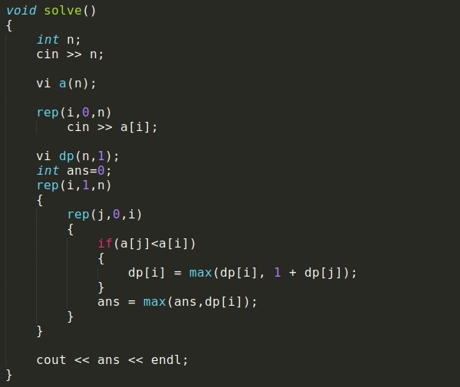

Code (Recursive)
